# NIST CSF 2.0: A New Horizon in Cybersecurity Evolution

Update, NIST CSF, Collaboration, Draft v2.0, Governance

August 17, 2023

[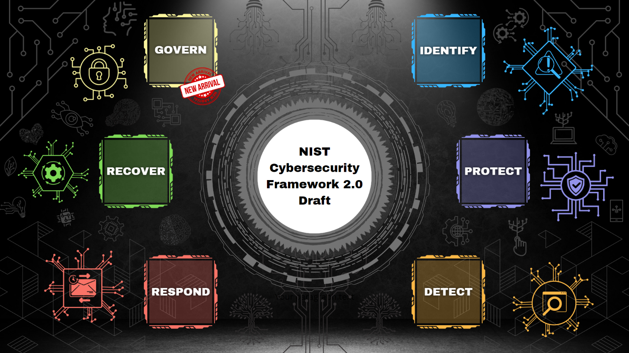](https://user-images.githubusercontent.com/131223318/261469849-f21b71de-6cff-4ef5-950a-22da566494f2.png)

As the digital landscape continues to evolve, organizations worldwide face an ever-growing challenge to secure their digital assets against increasingly sophisticated cyber threats. The National Institute of Standards and Technology (NIST) recognizes the need for a dynamic and adaptable cybersecurity framework, leading to the evolution of the NIST Cybersecurity Framework (CSF) from version 1.1 to version 2.0. This update, driven by community collaboration, a broader scope, enhanced guidance, and a comprehensive focus on cybersecurity governance, brings valuable opportunities for organizations to bolster their cybersecurity strategies.

## Recognizing the Broader Scope - A Global Paradigm Shift

In the evolution from NIST CSF version 1.1 to version 2.0, one of the most significant and resonant transformations is the framework's acknowledgment of a broader and more inclusive scope. By succinctly renaming the framework as the "Cybersecurity Framework," NIST has aligned its nomenclature with its ubiquitous use and recognition across industries and sectors. Beyond this, the paramount evolution lies in the expansion of the framework's applicability. No longer confined to a focus solely on critical infrastructure, CSF 2.0 extends its reach to encompass organizations of all sizes and types. This shift marks a watershed moment, signifying an elevated understanding of the universal nature of cyber threats and the imperative for comprehensive cybersecurity strategies that extend beyond specific sectors or entities.

The transition to a wider scope underscores a recognition that cyber threats transcend geographical and sectoral boundaries. The global reach of these threats necessitates a collective effort from organizations across industries to collectively bolster cyber resilience. In embracing this broader applicability, CSF 2.0 acknowledges that the imperatives of cybersecurity know no boundaries. Every organization, irrespective of size or sector, holds a responsibility to safeguard its digital assets, sensitive information, and critical operations. As prospective employers, this shift underscores the framework's adaptability and its potential to empower diverse entities to forge a united front against cyber adversaries. By leveraging CSF 2.0's principles, organizations can develop resilient cybersecurity strategies tailored to their specific needs while contributing to the overarching goal of a safer digital landscape.

## A Collaborative Journey - Excellence through Community Engagement

The journey from NIST CSF version 1.1 to version 2.0 is a testament to the power of collaboration within the cybersecurity community. NIST, recognizing the dynamic nature of cyber threats and the imperative for a robust framework, embarked on an extensive engagement with experts, practitioners, and organizations from diverse backgrounds. This collaborative approach ensures that CSF 2.0 aligns with not just theoretical ideals but also the practical realities faced by organizations in the ever-evolving digital landscape. By actively incorporating the wisdom of those on the front lines of cybersecurity, NIST has created a framework that resonates with real-world experiences and reflects the collective insights of the cybersecurity community.

The collaboration extends beyond the borders of CSF itself, as CSF 2.0 reaches out to reference other leading frameworks in the field. By referencing essential resources such as the NIST Privacy Framework and the NICE Workforce Framework for Cybersecurity, CSF 2.0 doesn't exist in isolation but rather as a part of a broader ecosystem of cybersecurity guidance. This integration underscores the interconnected nature of modern cybersecurity challenges and the need for a comprehensive approach that considers various aspects of risk management. Organizations can leverage this synergy to create a unified and holistic strategy that not only safeguards their digital assets but also aligns with established industry best practices.

This collaborative journey reflects the adaptability and relevance of CSF 2.0. It signifies that the framework is not a static document but a living, breathing entity shaped by the input of those who understand the intricacies of cybersecurity from various perspectives. By embracing CSF 2.0, organizations can tap into this wealth of collective expertise, ensuring that their cybersecurity strategies are not just theoretically sound but also grounded in the practical realities of the digital realm. The collaborative spirit that underpins CSF 2.0 fosters a sense of unity within the cybersecurity community, as organizations come together to bolster their defenses and navigate the challenges of a rapidly changing cybersecurity landscape.

## Guidance into Action - Empowering Cyber Resilience through Practicality

Within the transformation from NIST CSF version 1.1 to version 2.0 lies a pivotal enhancement that empowers organizations to translate guidance into tangible action. This enhancement takes the form of Implementation Examples, a feature designed to bridge the gap between theoretical concepts and practical implementation. These Implementation Examples offer a transformative approach, providing organizations with clear, action-oriented processes to achieve specific CSF subcategories. By breaking down complex cybersecurity concepts into executable steps, CSF 2.0 transforms guidance into a roadmap for concrete action, enabling organizations to implement cybersecurity best practices more effectively than ever before.

Expanding on the concept of actionable guidance, CSF 2.0 offers a comprehensive overhaul of Framework Profiles guidance. This update goes beyond the theoretical, offering step-by-step instructions that empower organizations to create profiles tailored to their unique circumstances. These profiles serve as blueprints for building a customized cybersecurity strategy, aligning with an organization's specific objectives, risk tolerance, and operational needs. The provision of templates for creating Profiles and action plans further streamlines the implementation process, offering organizations an adaptable starting point to craft their cybersecurity journey. This shift emphasizes the significance of practicality, as prospective employers are presented with tools that not only elucidate cybersecurity concepts but empower organizations to turn theory into reality, fostering a culture of proactive cybersecurity readiness.

In embracing the Implementation Examples and Framework Profiles, organizations gain more than theoretical knowledge—they acquire the means to apply cybersecurity concepts in meaningful ways. This practical approach not only enhances an organization's cybersecurity posture but also cultivates a mindset of proactive risk management. As prospective employers, this transformation reflects CSF 2.0's commitment to empowering organizations of all sizes and sectors to take actionable steps toward cyber resilience. It bridges the gap between theory and practice, ensuring that cybersecurity strategies are not just conceptual ideals but manifest as tangible safeguards against modern cyber threats. By capitalizing on these enhancements, organizations can foster a culture of cybersecurity efficacy and establish themselves as leaders in the ongoing battle against cyber adversaries.

## Governance at the Core - A Holistic Approach

At the heart of the evolution from NIST CSF version 1.1 to version 2.0 lies a profound emphasis on cybersecurity governance—a focal point that signifies a transformative shift in organizational cybersecurity leadership. Central to this transformation is the introduction of the "Govern" function within CSF 2.0. This multifaceted function stands as a beacon, illuminating the path toward comprehensive cybersecurity excellence by addressing critical aspects that encompass organizational context, risk management strategy, cybersecurity supply chain risk management, roles and responsibilities, policies, procedures, and oversight.

The "Govern" function serves as a strategic hub that elevates cybersecurity from a mere technical consideration to an enterprise-wide imperative. It recognizes that cybersecurity is no longer confined to the domain of IT; rather, it permeates every facet of an organization's operations. By encompassing organizational context, the function positions cybersecurity within the broader strategic context, aligning it with an organization's overarching mission, values, and business objectives. The inclusion of risk management strategy acknowledges that cybersecurity is inseparable from risk considerations. It underscores the importance of an integrated approach where cybersecurity is an essential dimension of overall risk management, emphasizing the interconnectedness of operational and digital risk.

CSF 2.0's emphasis on cybersecurity supply chain risk management within the "Govern" function attests to the increasing recognition of the ripple effects of cyber threats throughout interconnected networks. This acknowledgement empowers organizations to address vulnerabilities that can emanate from third-party vendors, underscoring the critical importance of securing every link in the digital supply chain. The "Govern" function also dedicates attention to roles, responsibilities, policies, and procedures, reinforcing that cybersecurity is not an abstract concept but a set of concrete actions and accountabilities that involve everyone within the organization. By offering a framework for oversight, it ensures that cybersecurity strategies are not only implemented but consistently monitored and improved upon.

The prominence of the "Govern" function in CSF 2.0 signifies a seismic shift in the way cybersecurity is perceived and managed. It invites organizations to embrace a holistic approach where cybersecurity is a strategic imperative and an organizational culture that is deeply ingrained. By championing this comprehensive view of cybersecurity governance, organizations can position themselves as leaders in cybersecurity readiness and resilience. They can build a culture where cybersecurity is not merely a technical concern but a collaborative effort that transcends departments and functions, safeguarding operations, sensitive data, and digital initiatives alike. This renewed focus on cybersecurity governance within CSF 2.0 positions organizations to thrive in an era where digital risks are a constant, affirming their commitment to cyber excellence.

## Mitigating Supply Chain Risks - Resilience through Vigilance

In the realm of evolving cyber threats, where digital systems intricately interweave, the significance of supply chain security has surged to the forefront of cybersecurity discourse. A pivotal juncture in the transformation from NIST CSF version 1.1 to version 2.0 lies in the acknowledgment of this critical facet. Within the overarching "Govern" function, CSF 2.0 crafts a dedicated category laser-focused on cybersecurity supply chain risk management. This visionary inclusion underscores an acute awareness of the cascading effects a supply chain breach can unleash and positions supply chain security as an instrumental cornerstone in fortifying overall cybersecurity resilience.

The introduction of a supply chain-centric category within the "Govern" function signifies a paradigm shift in addressing vulnerabilities that emanate from an organization's digital supply chain. This strategic recalibration highlights the interconnected nature of digital systems and their potential to ripple vulnerabilities across ecosystems. CSF 2.0's alignment with NIST's latest guidance on supply chain risk management and secure software development underscores its commitment to equipping organizations with the tools and strategies required to mitigate risks originating from the complex digital supply chain. By embracing this focused approach, organizations gain the insight and guidance needed to assess, manage, and enhance the security of their supply chains. This strategic emphasis ensures that as prospective employers, organizations are poised to tackle not only direct cyber threats but also those that can infiltrate their operations through intricate supply chain interdependencies.

The inclusion of supply chain risk management within CSF 2.0 serves as a call to arms for organizations, beckoning them to embrace a holistic view of cybersecurity that extends beyond their own digital walls. It amplifies the concept that an organization's cybersecurity resilience is as strong as its weakest link—often found within the intricate threads of the supply chain. By engaging with this dedicated category, organizations can fortify their defenses, identify vulnerabilities, and implement strategies to insulate themselves from supply chain-borne cyber threats. This emphasis also underscores an organization's commitment to comprehensive risk management, positioning them as leaders in cybersecurity excellence. As organizations navigate the complex digital landscape, CSF 2.0's supply chain risk management offers a guiding light, illuminating a pathway to resilience against the evolving challenges of a modern interconnected world.

## Measuring Progress and Adaptability - Forging the Path to Excellence

When threats evolve at a relentless pace, the ability to measure progress and foster continuous improvement is paramount. CSF 2.0, in its journey from version 1.1, casts a spotlight on this crucial facet, ushering organizations into a realm where cybersecurity isn't a static destination but an ongoing journey of growth. Anchored within this evolution is a strategic focus on measuring progress; a commitment that echoes across every corner of the framework.

CSF 2.0's approach to measuring progress is multidimensional, underpinned by a standardized methodology informed by NIST's SP 800-55. This harmonized approach ensures that organizations no longer navigate the assessment landscape with uncertainty but wield a structured framework to gauge their cybersecurity posture. Within this construct, the tier structure has been meticulously refined, positioning cybersecurity governance, risk management, and third-party considerations at its core. This recalibration signals an alignment with the modern cybersecurity landscape, where resilience isn't merely technical—it's a fusion of strategic governance, astute risk mitigation, and a keen awareness of interdependent relationships.

A defining chapter within CSF 2.0's evolution is the introduction of the "Improvement" category—a clarion call for organizations to not rest on their laurels but to continuously elevate their cybersecurity posture. This category breathes life into the principle of adaptability, emphasizing that cybersecurity strategies are living entities that demand nurturing and enhancement. It's here that prospective employers encounter an unparalleled avenue for development—enhanced guidance on the development and updating of Framework Profiles. This guidance equips organizations with the tools to refine their cybersecurity strategies over time, aligning them with emerging threats, technological advancements, and shifting organizational landscapes.

The commitment to measuring progress and adaptability within CSF 2.0 is more than just an evolution—it's a testament to a mindset that embraces change as a catalyst for cybersecurity excellence. As prospective employers, this transformation offers a compelling narrative for organizations seeking to establish themselves as dynamic leaders in the cybersecurity realm. By harnessing the tools provided within CSF 2.0, organizations not only fortify their digital defenses but cultivate a culture that thrives on vigilance, growth, and the perpetual pursuit of cybersecurity excellence.

## Reflections - The Future of Cybersecurity

The journey from NIST CSF version 1.1 to version 2.0 encapsulates the dynamic evolution of cybersecurity, marked by adaptability, collaboration, and an unwavering pursuit of excellence. More than an update, CSF 2.0 charts a course towards heightened cyber resilience, comprehensive governance, practical implementation, and measurable progress. This transformation underscores the universal nature of cybersecurity threats, uniting organizations of all sizes and sectors in a collective mission to counter modern cyber challenges on a global scale.

Built upon collaboration, the transition from CSF 1.1 to 2.0 highlights the power of community engagement, pooling expertise from diverse corners of cybersecurity to shape a framework that resonates with real-world complexities. The evolution from theoretical guidance to actionable strategies, illustrated through Implementation Examples, empowers organizations to translate cybersecurity principles into tangible defenses, fostering a culture of proactive readiness and resilience.

At the heart of CSF 2.0 lies a renewed emphasis on cybersecurity governance—a profound shift that integrates cybersecurity seamlessly into an organization's strategic fabric. The introduction of a dedicated supply chain risk management category within the "Govern" function acknowledges the intricate web of digital dependencies. Embracing this transformation goes beyond cybersecurity investment; it signifies a commitment to holistic risk management and a display of leadership amidst modern threats.

CSF 2.0 is more than a framework; it's a dynamic force that beckons organizations to measure progress, cultivate adaptability, and continually strive for cybersecurity excellence. The "Improvement" category serves as a reminder that cybersecurity is a perpetual journey, guided by practicality and the shared ambition to forge a safer digital landscape. As we conclude this exploration of NIST CSF 2.0's evolution, let's remember that while the framework equips with tools, the true power lies within organizations to drive change, fortify defenses, and navigate the ever-evolving currents of the digital realm with unyielding confidence.

# Resources:

* [[Click Here]](https://www.nist.gov/news-events/news/2023/08/nist-drafts-major-update-its-widely-used-cybersecurity-framework) *NIST: Drafts Major Update to Its Widely Used CSF (2023)*
* [[Click Here]](https://www.nist.gov/system/files/documents/2022/10/03/NIST_CSF_update_Fact_Sheet.pdf) *NIST: Cybersecurity Framework 2.0 (2022)*
* [[Click Here]](https://csrc.nist.gov/pubs/ir/8477/ipd) *NIST (IR 8477): Discussion Draft of the Implementation Examples (2023)*
* [[Click Here]](https://www.engage.hoganlovells.com/knowledgeservices/news/nist-prepares-for-cybersecurity-framework-20-with-increased-focus-on-governance-and-supply-chain) *Hogan Lovells Engage: NIST prepares for CSF 2.0, with increased focus on governance and supply chain (2023)*
* [[Click Here]](https://medium.com/databulls/new-nist-cybersecurity-framework-2-0-draft-publication-what-are-possible-changes-303035162e07) *Medium: New NIST CSF 2.0 – Draft Publication – What are possible changes? (2023)*
* [[Click Here]](https://blog.isc2.org/isc2_blog/2023/02/analysis-could-nists-cybersecurity-framework-20-be-the-beginning-of-international-best-practice.html) *ISC2: ANALYSIS - COULD NIST’S CSF 2.0 BE THE BEGINNING OF INTERNATIONAL BEST PRACTICE? (2023)*
* [[Click Here]](https://blog.riskrecon.com/the-nist-cybersecurity-framework-2.0-what-it-is-and-why-its-changing) *RiskRecon: The NIST CSF 2.0: What It Is and Why It's Changing (2023)*
* [[Click Here]](https://blogs.cisco.com/government/hear-the-latest-on-nists-cybersecurity-framework-2-0-and-beyond) *Cisco: Hear the Latest on NIST’s CSF 2.0 (and Beyond) (2023)*
* [[Click Here]](https://www.infosectrain.com/blog/nist-cybersecurity-framework/) *Infosec Train: NIST CSF 2.0 (2023)*
* [[Click Here]](https://healthitsecurity.com/news/nist-releases-draft-of-expanded-cybersecurity-framework) *HealthITSecurity: NIST Releases Draft of Expanded CSF (2023)*